Objective Questions Chapter 13
1. If L is a language accepted by some Turing machine M, then
(a) w Є L’ must be rejected by M.
(b) running M with w Є L initially loaded on the TAPE will result in M ending in a HALT state.
(c) L must be a nonregular language.
(d) L must be a regular language
2.
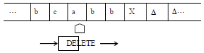
From tape above, which string will be deleted, and the string result is :
a) deleted = a ; result = bcbbb
b) deleted = a ; result = bcabb
c) deleted = a ; result = bbcab
d) deleted = b ; result = bcabc
3.
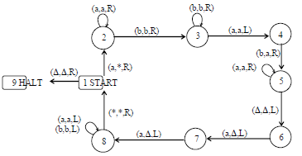
The string aaabbbaaa can be observed to be accepted by the above TM. It can also be observed that the above TM accepts the non-CFL is :

a) {a^{n}b^{n}a^{n}}
b) {a^{n}b^{n\}}
c) {ab^{n}a^{n}}
d) {a^{n}b^{n}a^{n+1}}
4.
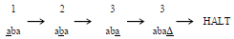
Which shows that the string aba is accepted by this machine. It can be observed, from the program of the TM, that the machine accepts the language expressed by :
a) (a+b)a(a+b)*
b) (a+b)(a+b)*
c) (a+b)b(a+Λ)*
d) (a+b)b(a+b)*
5. If the transition is δ(q₁,a) = (q₁,a,R) causing the head write a and move to :
a) right
b) left
c) 2 steps right
d) All answer is wrong.
6. Who had found the configuration of turing machine ?
a) Alan Turing
b) Ahmed Turing
c) Aan turing
d) Al Hafiz Turing
7. Suppose L is a language generated by a regular grammar, and consider the following
statements:
(i) L is a regular language.
(ii) L is a context-free language.
(iii) There is a Turing machine that accepts L.
Which of the following is correct?
(a) Only statement (i) is true.
(b) Only statement (ii) is true.
(c) Only statement (iii) is true.
(d) Only statements (i) and (ii) are true.
(e) Only statements (i) and (iii) are true.
(f) Only statements (ii) and (iii) are true.
(g) All 3 statements are true.
(h) None of the 3 statements is true.
8. If L is accepted by a finite automaton, then
(a) there must exist some Turing machine that accepts L.
(b) there must not exist some Turing machine that accepts L.
(c) there may or may not exist some Turing machine that accepts L.
(d) No answer is correct
9.
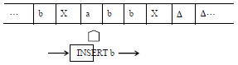

From the above picture, we can conclude that :
a) letter a inserted
b) letter b inserted
c) No letter inserted
d) No answer is correct
10.
From the picture above, we can conclude that :
a) letter b is deleted
b) letter a is deleted
c) no letted will be deleted
d) All answers is wrong

